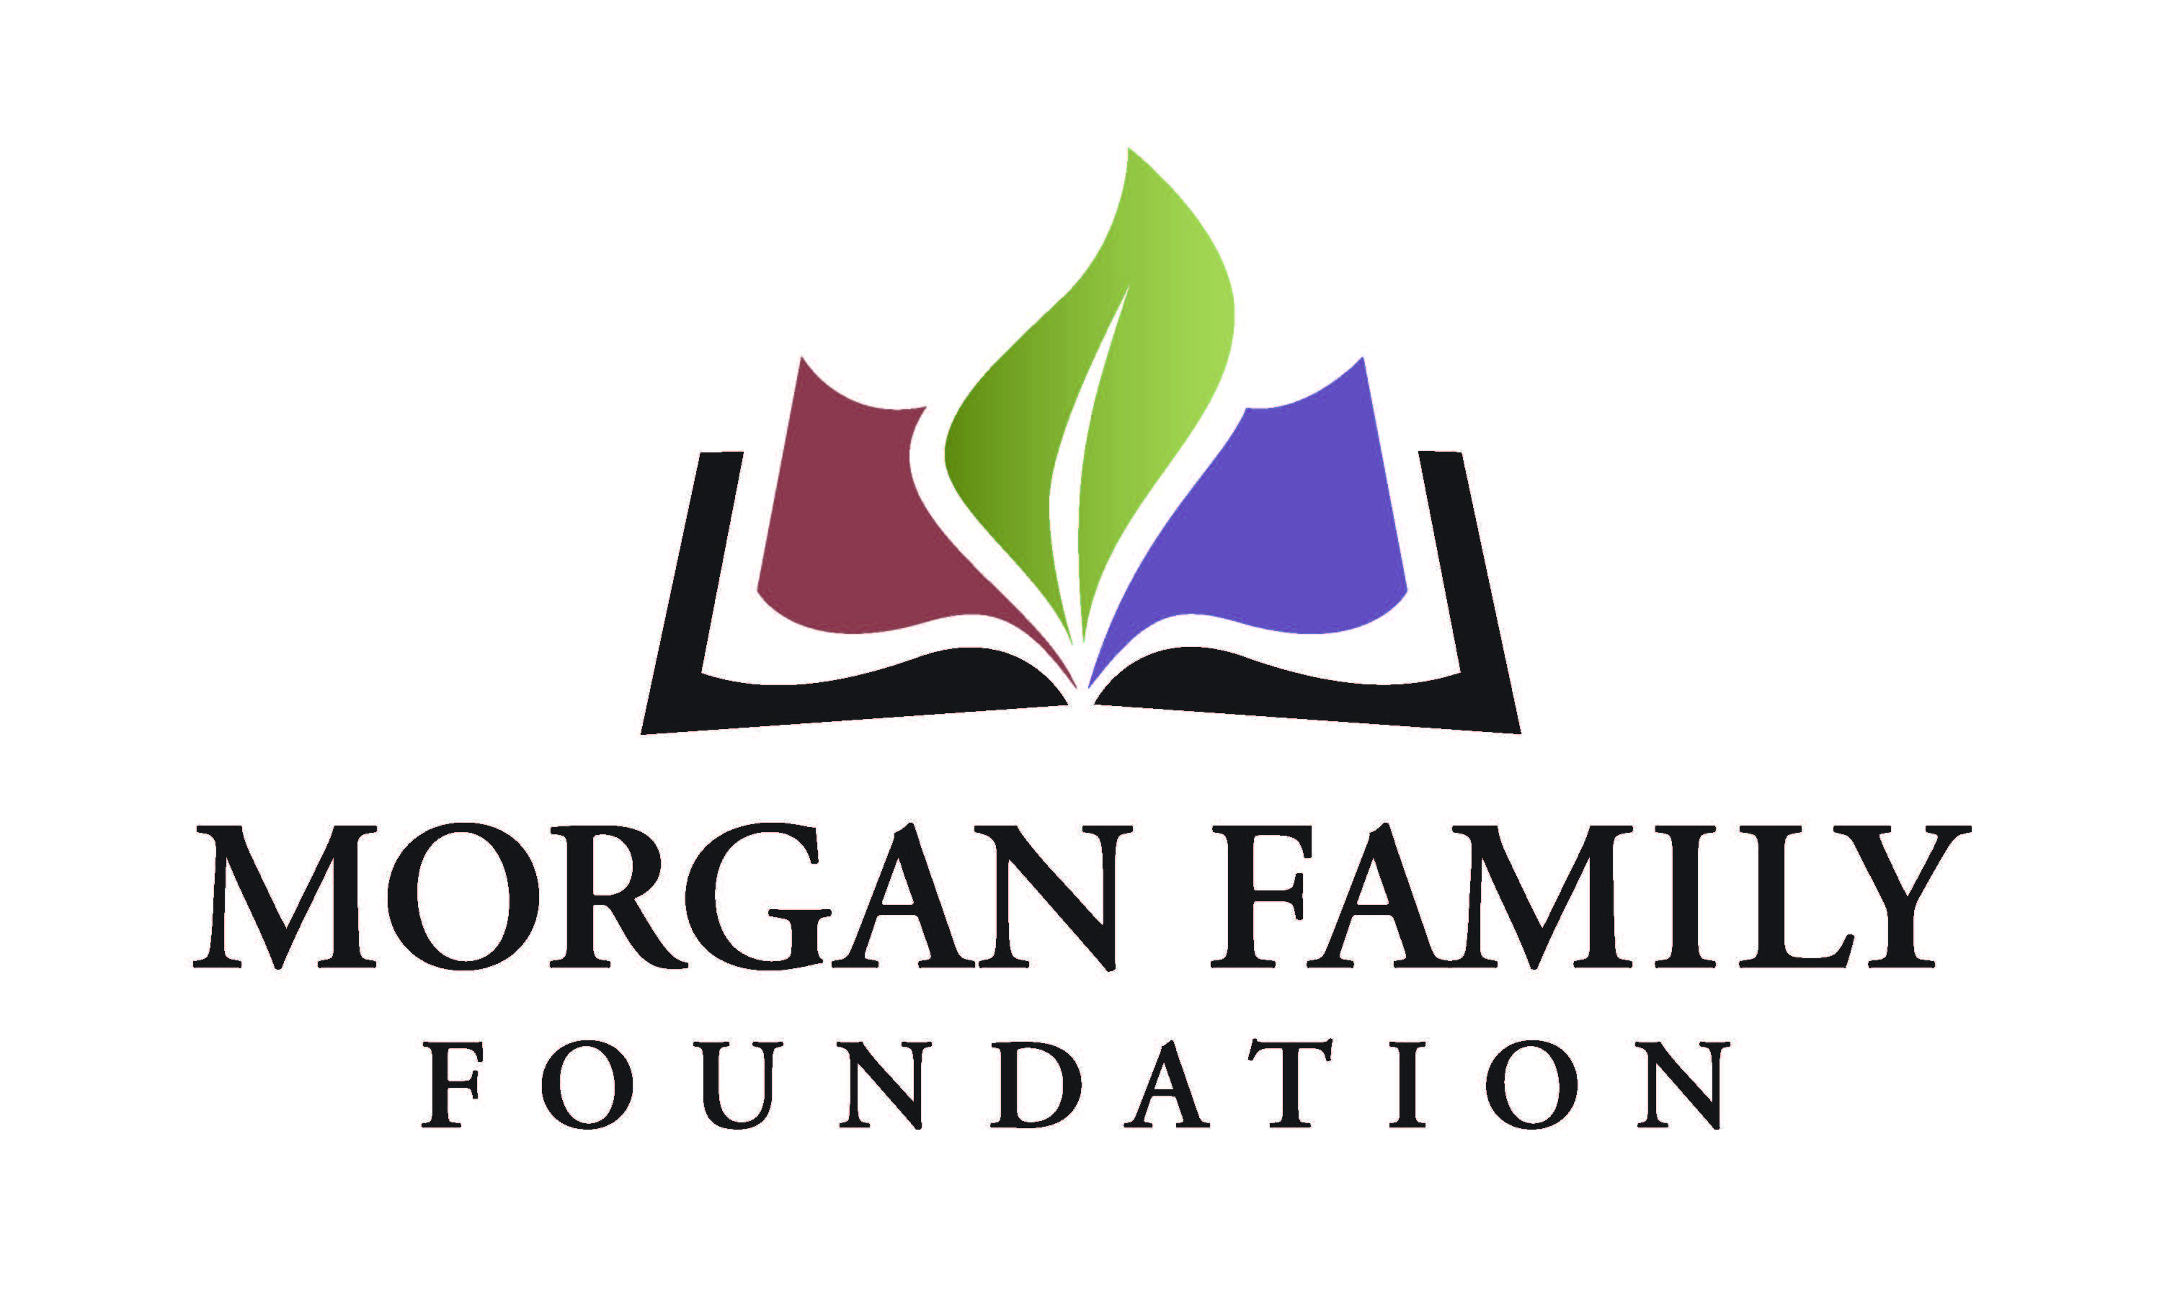
Grant Application: End of Life Renewal
Required Information for 2026
This document is provided for reference only. Please do not attempt to use this as an application, which is by invitation only and must be submitted online using the GivingData application portal.
The following information is required for submission of an End of Life Grant Application. [Bracketed items] are not required, but are requested/optional and may not be applicable for a particular request.
Organization Data
- Full Legal Organization Name
- Employer Tax Identification Number (EIN)
- [Other name, if different (AKA/Also Known As, DBA/Doing Business As, or project name if applicant is utilizing a fiscal sponsor)]
- Address Line 1
- [Address Line 2]
- City, State, Zip, Country
- [Secondary Organization Address]
- [Organization Email Address]
- [Organization Website]
- Organization Phone Number
- [Organization Fax Number]
- Organization’s Mission/Purpose
- What is your organization’s tax status? 501(c)(3) Public Charity; Public agency/unit of government; Using Fiscal Sponsor; Other/Unsure
- [Full Legal Name of Fiscal Sponsor]
- [EIN of Fiscal Sponsor]
- Total annual organization budget for current fiscal year & fiscal year ending date
Contact Information
- Name of top (paid) staff person [prefix, suffix]
- Title [Department]
- [Pronouns]
- E-mail
- Phone
- Name of contact person regarding this application [prefix, suffix]
- Title [Department]
- [Pronouns]
- E-mail
- Phone
- Name of Payment Contact [prefix, suffix]
- Title [Department]
- [Pronouns]
- E-mail
- Phone

Request Data
- Request Title
- Dollar Amount Requested
- Total Grant/Project Budget
- Please give a brief summary of the grant purpose. Please write a concise response. Most people write about 2-3 sentences.
- Type of support that is being requested (check all that apply): __General operating support __Start-up costs __Capital request __Project/program support __Capacity building __Advocacy __Other
- [If other, briefly describe what is needed]
- Briefly elaborate about the geographic area served by naming the counties, cities, communities, etc. as appropriate that are the focus of your proposed grant.
Proposal Narratives (narrative responses required)
- What professional skills, lived experiences and community connections are represented on your board?
- Briefly describe how your proposal to renew grant funding builds on the work you did in the previous year to address end of life issues.
- Will the work serve the same region, community, or demographic in Minnesota? Please elaborate on any significant differences.
- Will the work involve the same partners, communities, and organizations that you worked with in the previous year? Please elaborate on significant differences in the composition or roles.
- Have there been any significant changes in your organization’s capacity to implement your proposal (volunteers, partnerships, reputation, finances, etc.)?
- Please provide details about the implementation steps and timetable if you receive this funding.
  - Grant start date (MM/DD/YYYY)
  - Grant end date (MM/DD/YYYY)
  - Suggested mid-term verbal check-in date (MM/DD/YYYY)
  - Suggested grant final report due date (MM/DD/YYYY – typically due ~1 month after grant end date)
- Please provide three specific measurable outcomes for your proposal.
- Is your organization undergoing any regulatory investigations, legal system involvement or significant personnel transitions? Is there anything else the Foundation should know related to this grant request, your organization, or its leadership? Please describe below, upload an attachment, or indicate your request for verbal communication, as appropriate.

Attachments
- Financial statement from most recently completed fiscal year, audited if available, showing actual expenses. This information should include a statement of financial position, statement of revenue and expense, and statement of activities (functional expenses).
- Organization’s budget for current year, including income and expenses.
- [Grant/Project budget, including income and expenses (if not a general operating proposal).]
- [Additional funders. List names of corporations, foundations or any other sources from which you are requesting funds for this project, with dollar amounts, indicating which sources are committed or pending.]
- List of board members and their affiliations.
- [To be completed only if applicant is utilizing a fiscal sponsor for this request: Written agreement between the fiscal sponsor/applicant organization and the project and, if not explicit in the agreement, a letter stating that the sponsor accepts full legal, fiscal, and programmatic responsibility for the project.]
- [To be completed only if applicant is utilizing a fiscal sponsor for this request: List of the fiscal sponsor’s leadership and advisory committee members and their affiliations.]

Organization’s Demographic Data: Please provide the number and demographics of board members and staff (full-time and part-time).
The system will display the information currently shared on Candid about your organization’s demographics. We do not currently require this information to be submitted to Candid; however, we strongly encourage you to do so and keep this information up-to-date.
If your organization does not have its board and staff demographic data available on Candid, please provide the information below. If your organization’s demographics on Candid are accurate and up-to-date, type “See Candid data.”

Authorization:
- Have you used generative artificial intelligence (such as ChatGPT, Google Gemini, Fundwriter.ai, etc.) to assist in completing this application?
- [Which application(s) did you use?]
The system will prompt the top paid staff or board chair to type their name, title, and date, certifying authorization to submit this grant request on behalf of the organization, and that, to the best of their knowledge, the information contained therein is true, accurate, and complete.

