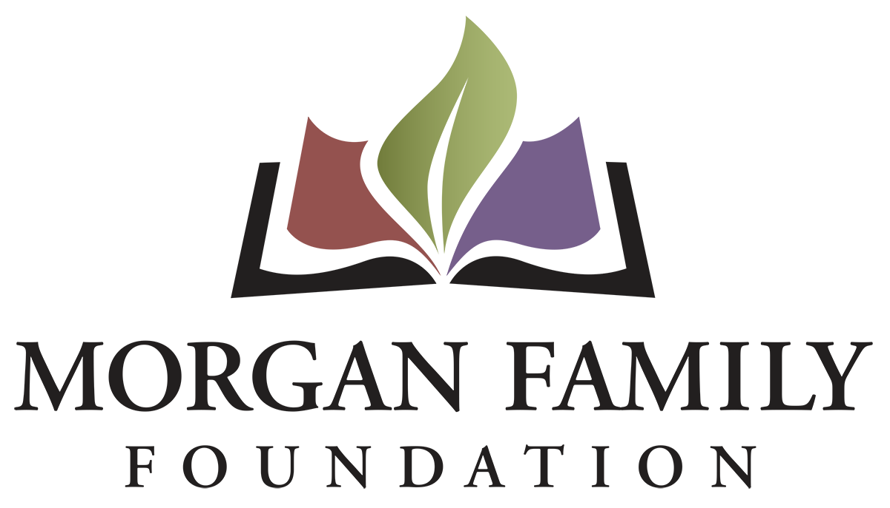
Grant Application: Global Warming in Minnesota –
Required Information for 2026
This document is provided for reference only. Please do not attempt to use this as an application, which is by invitation only and must be submitted online using the GivingData application portal.
The following information is required for submission of a Global Warming grant application. [Bracketed items] are not required but are requested/optional and may not be applicable for a particular request.
Organization Information
- Legal name of organization
- Applicant organization’s employer identification number (EIN)
- [Other name, if different (AKA/Also Known As, DBA/Doing Business As, or project name if applicant is serving as a fiscal sponsor)]
- Address Line 1
- [Address Line 2]
- City, State, Zip
- [Secondary Organization Address]
- [Organization Email Address]
- [Organization Website]
- Organization Phone Number
- [Organization Fax Number]
- Please give a 2-3 sentence summary of the organization’s purpose and/or its mission statement.
- Total annual organization budget for current fiscal year & fiscal year ending date
- What is your organization’s tax status? 501(c)(3) Public Charity; Public agency/unit of government; Using Fiscal Sponsor; Other/Unsure
- [Full Legal Name of Fiscal Sponsor]
- [EIN of Fiscal Sponsor]
Contact Information
- Name of top (paid) staff person [prefix, suffix]
- Title [Department]
- [Pronouns]
- Phone
- E-mail
- Name of contact person regarding this application [prefix, suffix]
- Title [Department]
- [Pronouns]
- Phone
- E-mail
- Name of Payment Contact [prefix, suffix]
- Title [Department]
- [Pronouns]
- E-mail
- Phone
Proposal Information
- Grant/Project Title
- Please give a brief summary of the grant purpose
- Briefly elaborate about the geographic area served. Name the counties, cities, communities, etc. as appropriate that are the focus of your proposed grant.
- What are grant funds being requested for (check all that apply): __General operating support __Start-up costs __Capital __Project/program support __Capacity Building __Advocacy __Other (if other, briefly describe what is needed)
Proposal Narratives (narrative responses required)
- Please share a brief organizational history, including a summary of current programs and activities.
- What professional skills, lived experiences and community connections are represented on your board?
- What part of mitigating global warming in Minnesota do you propose to address? Briefly describe what your proposal will do to address this.
- What region, community, or demographic in Minnesota will this work serve? Please elaborate on the importance of this.
- Who will be involved in development, implementation, and evaluation of the grant? Describe your relationship to the region, partners, communities, and organizations that you will work with.
- Describe how this work will result in broadening the demographics of Minnesotans engaged in mitigating global warming, increase understanding of global warming in Minnesota, or support technologies or actions that mitigate the impacts of global warming.
- Briefly describe how this work builds on past work done by your organization and other organizations.
- What is your organization’s capacity to implement your proposal (volunteers, partnerships, reputation, finances, etc.)?
- Please provide details about the implementation steps and timetable if you receive this funding.
  - Request start date (MM/DD/YYYY)
  - Request end date (MM/DD/YYYY)
  - Suggested mid-term grant check-in date (MM/DD/YYYY)
  - Suggested grant final report due date (MM/DD/YYYY – typically due ~1 month after grant end date)
- Please provide three specific measurable outcomes for your proposal.
- Is your organization undergoing any regulatory investigations, legal system involvement or significant personnel transitions? Is there anything else the Foundation should know related to this grant request, your organization, or its leadership? Please describe below, upload an attachment, or indicate your request for verbal communication, as appropriate.

Financial Information
- Requested grant amount
- Total grant/project budget
- Grant/project budget, including detailed expenses and sources of income. Please list below and/or upload an expense budget with detail.
- Total annual organization budget for current fiscal year & fiscal year ending date
- Financial highlights for most recently completed fiscal year (revenue, expenses, assets, liabilities, unrestricted net assets, and data source)
- Attachment: Financial statement from most recently completed fiscal year, audited if available, showing actual expenses. This information should include a statement of financial position, statement of revenue and expense, and statement of activities (functional expenses).

[Organization’s Demographic Data: The system will display the information currently shared about your organization’s demographics on Candid. We do not currently require this information; however, we strongly encourage you to keep this information completed and current.]

Authorization:
- Have you used generative artificial intelligence (such as ChatGPT, Google Gemini, Fundwriter.ai, etc.) to assist in completing this application?
- [Which application(s) did you use?]
The system will prompt the top paid staff or board chair to type their name, title, and date, certifying authorization to submit this grant request on behalf of the organization, and that, to the best of their knowledge, the information contained therein is true, accurate, and complete.

