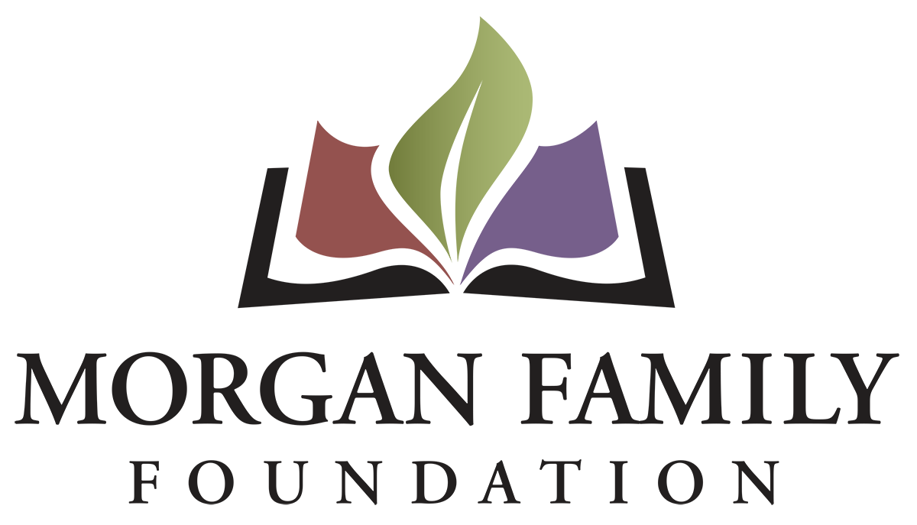
Grant Application: Global Warming in Minnesota Renewals – Required Information for 2026
This document is provided for reference only. Please do not attempt to use this as an application, which is by invitation only and must be submitted online using the GivingData application portal.
The following information is required for submission of a Global Warming grant application. [Bracketed items] are not required but are requested/optional and may not be applicable for a particular request.
Organization Information
- Legal name of organization
- Applicant organization’s employer identification number (EIN)
- [Other name, if different (AKA/Also Known As, DBA/Doing Business As, or project name if applicant is serving as a fiscal sponsor)]
- Address Line 1
- [Address Line 2]
- City, State, Zip
- [Secondary Organization Address]
- [Organization Email Address]
- [Organization Website]
- Organization Phone Number
- [Organization Fax Number]
- Please give a 2-3 sentence summary of the organization’s purpose and/or its mission statement.
- What is your organization’s tax status? 501(c)(3) Public Charity; Public agency/unit of government; Using Fiscal Sponsor; Other/Unsure
- [Full Legal Name of Fiscal Sponsor]
- [EIN of Fiscal Sponsor]
Contact Information
- Name of top (paid) staff person [prefix, suffix]
- Title [Department]
- [Pronouns]
- Phone
- E-mail
- Name of contact person regarding this application [prefix, suffix]
- Title [Department]
- [Pronouns]
- Phone
- E-mail
- Name of Payment Contact [prefix, suffix]
- Title [Department]
- [Pronouns]
- E-mail
- Phone

Proposal Summary
- Grant/Project Title
- Please give a brief summary of the grant purpose
- Briefly elaborate about the geographic area served. Name the counties, cities, communities, etc. as appropriate that are the focus of your proposed grant.
- What are grant funds being requested for (check all that apply): __General operating support __Start-up costs __Capital __Project/program support __Capacity Building __Advocacy __Other (if other, briefly describe what is needed)
Proposal Narratives (narrative responses required)
- What professional skills, lived experiences and community connections are represented on your board?
- Briefly describe how your proposal to renew grant funding builds on the work you did in the previous year to address global warming.
- Will the work serve the same region, community, or demographic in Minnesota? Please elaborate on any significant differences.
- Will the work involve the same partners, communities, and organizations that you worked with in the previous year? Please elaborate on significant differences in the composition or roles.
- Have there been any significant changes in your organization’s capacity to implement your proposal (volunteers, partnerships, reputation, finances, etc.)?
- Please provide details about the implementation steps and timetable if you receive this funding.
- Grant start date (MM/DD/YYYY)
- Grant end date (MM/DD/YYYY)
- Suggested mid-term grant check-in date (MM/DD/YYYY)
- Suggested grant final report due date (MM/DD/YYYY – typically due ~1 month after grant end date)
- Please provide three specific measurable outcomes you will achieve with an additional year of funding.
- Is your organization undergoing any regulatory investigations, legal system involvement or significant personnel transitions? Is there anything else the Foundation should know related to this grant request, your organization, or its leadership? Please describe below, upload an attachment, or indicate your request for verbal communication, as appropriate.

Financial Information
- Requested grant amount
- Total grant/project budget
- Grant/project budget, including detailed expenses and sources of income. Please list below and/or upload a budget with detail.
- Total annual organization budget for current fiscal year & fiscal year ending date
- Financial highlights for most recently completed fiscal year (revenue, expenses, assets, liabilities, unrestricted net assets, and data source)
- Attachment: Financial statement from most recently completed fiscal year, audited if available, showing actual (rather than budgeted or projected) figures. This information should include a statement of financial position, statement of revenue and expense, and statement of activities (functional expenses).
- Additional funders. List names of corporations, foundations or any other sources from which you are requesting funds for this project, with dollar amounts, indicated which sources are committed or pending.
- List of board members and their affiliations.

[Fiscal Sponsorship Information:
- Please upload a list of the project’s leadership and advisory committee members and their affiliations.
- Please attach the written agreement between the fiscal sponsor/applicant organization and the project and, if not explicit in the agreement, a letter stating that the sponsor accepts full fiscal, legal, and programmatic responsibility for the project.]

[Organization’s Demographic Data: The system will display the information currently shared about your organization’s demographics on Candid. We do not currently require this information; however, we strongly encourage you to keep this information completed and current.]

Authorization:
- Have you used generative artificial intelligence (such as ChatGPT, Google Gemini, Fundwriter.ai, etc.) to assist in completing this application?
- [Which application(s) did you use?]
The system will prompt the top paid staff or board chair to type their name, title, and date, certifying authorization to submit this grant request on behalf of the organization, and that, to the best of their knowledge, the information contained therein is true, accurate, and complete.

