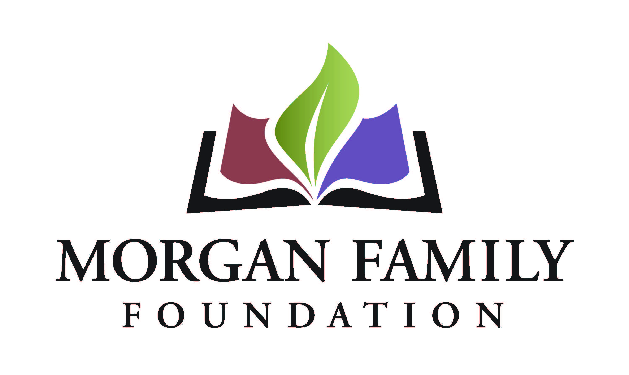
Full Grant Application: Social Equity - Required Information, 2026
When invited to submit a full grant application, you will have the opportunity to review and update the “fill-in-the-blank” information submitted as part of your Letter of Inquiry. In addition, the following information is required for submission of a Full Grant Application. [Bracketed items] are not required, but they are requested/optional and may not be applicable for a particular request.
Contact Information
- Name of Payment Contact [prefix, suffix]
- Title [Department]
- [Pronouns]
- E-mail
- Phone
Organization Narrative Questions
- Please share a brief organizational history, including a summary of current programs and activities. Please highlight any components that address long-standing barriers, expand opportunity for all, and advance community-led solutions.
- What professional skills, lived experiences and community connections are represented on your board?
- Describe the nature of your organization’s relationship with other organizations working with similar missions. What is your role relative to these other organizations?

Proposal Narrative Questions
- Review and update, as needed, the description of the underserved community that you aim to assist. Approximately how many people will be served through this grant?
- Describe the positive outcomes for this community if the grant is successful.
- Review and update, as needed, the following information from your Letter of Inquiry (LOI) which describes: (1) the unfair and persistent barrier or gap that your grant will address; (2) the harm caused by that barrier or gap; (3) what your grant will do to (a) reduce the barrier / close the gap and expand opportunities for all and (b) make changes in attitudes, practices, or policies to achieve positive outcomes; and (4) how you identified this barrier or gap.
- Review and update, as needed, the three measurable outcomes previously provided. Identify the specific activities you will use to achieve each of those outcomes.
- Describe how you will know that your outcomes have been achieved. How will you assess this and what methods and tools will you use to capture data to evaluate this grant?
- Identify other organizations, if any, participating in the project. If applicable, provide summary descriptions of those organizations’ work related to this project that expands opportunities for all.
- Summarize plans for continuation of the project after the grant, if applicable.
- Please provide details on the implementation steps and timetable if you receive this funding.
  - Grant start date (MM/DD/YYYY)
  - Grant end date (MM/DD/YYYY)
  - Suggested mid-term grant check-in date (MM/DD/YYYY)
  - Suggested final grant report due date (MM/DD/YYYY – typically due ~1 month after grant end date)
- Is your organization undergoing any regulatory investigations, legal system involvement or significant personnel transitions? Is there anything else the Foundation should know related to this grant request, your organization, or its leadership? Please describe below, upload an attachment, or indicate your request for verbal communication, as appropriate.
Attachments
- Financial statement from most recently completed fiscal year, audited if available, showing actual expenses. This information should include a statement of financial position, statement of revenue and expense, and statement of activities (functional expenses).
- Organization’s budget for current year, including income and expenses.
- [Project budget, including income and expenses (if not a general operating proposal).]
- [Additional funders. List names of corporations, foundations or any other sources from which you are requesting funds for this project, with dollar amounts, indicating which sources are committed or pending.]
- List of board members and their affiliations.
- [To be completed only if applicant is utilizing a fiscal sponsor for this request: Written agreement between the fiscal sponsor/applicant organization and the project and, if not explicit in the agreement, a letter stating that the sponsor accepts full legal, fiscal, and programmatic responsibility for the project.]
- [To be completed only if applicant is utilizing a fiscal sponsor for this request: List of the fiscal sponsor’s leadership and advisory committee members and their affiliations.]

Organization’s Demographic Data: Please provide the number and demographics of board members and staff (full-time and part-time).
The system will display the information currently shared on Candid about your organization’s demographics. We do not currently require this information to be submitted to Candid; however, we strongly encourage you to do so and keep this information up to date.
If your organization does not have its board and staff demographic data available on Candid, please provide the information below. If your organization’s demographics on Candid are accurate and up-to-date, type “See Candid data.”

Authorization:
- Have you used generative artificial intelligence (such as ChatGPT, Google Gemini, Fundwriter.ai, etc.) to assist in completing this application?
- [Which application(s) did you use?]
- The system will prompt the top paid staff or board chair to type their name, title, and date, certifying authorization to submit this letter of inquiry on behalf of the organization, and that, to the best of their knowledge, the information contained therein is true, accurate, and complete.

