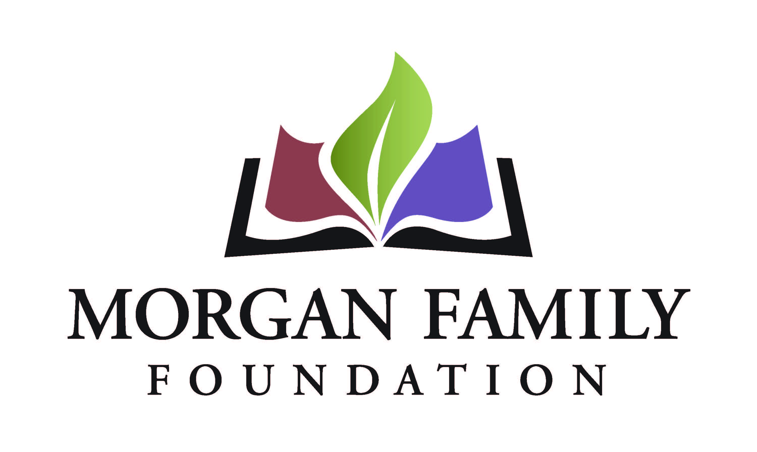
Full Grant Application: Social Equity - Required Information for 2024
When invited to submit a full grant application, you will have the opportunity to review and update the “fill-in-the blank” information submitted as part of your Letter of Inquiry. In addition, the following information is required for submission of a Full Grant Application. [Bracketed items] are not required, but they are requested/optional and may not be applicable for a particular request.
Organization Narrative Questions
- Please share: (1) a brief organizational history; (2) a summary of organizational goals; (3) a brief description of current programs and activities; (4) recent accomplishments or achievements; and (5) any recent major changes to financial and/or organizational circumstances. For all responses above, please highlight any components that advance diversity, equity and inclusion.
- Describe the nature of your organization’s relationship with other organizations working with similar missions. What is your role relative to these other organizations?

Proposal Narrative Questions
- Review and update as needed, the demographics of the disadvantaged community who will be impacted. Approximately how many people will be served through this grant?
- Review and elaborate on the positive outcomes for this community if the grant is successful.
- Review and update, as needed, the following information from your Letter of Inquiry (LOI) which describes: (1) the unfair disparity that your grant will address; (2) the harm caused by the disparity; (3) what your grant will do to (a) reduce the disparity and (b) make changes in attitudes, practices, or policies to achieve positive outcomes; and (4) how you identified this disparity.
- Review and update, as needed, the three measurable outcomes previously provided. Identify the specific activities you will use to achieve each of those outcomes.
- Describe how you will know that your outcomes have been achieved. How will you assess this and what methods and tools will you use to capture data to evaluate this grant?
- Identify other organizations, if any, participating in the project. If applicable, provide summary descriptions of any inequity reduction work in which those organizations have been involved related to this project.
- Summarize plans for continuation of the project after the grant, if applicable.
- Please review, edit, and expand on the implementation steps and timetable if you receive this funding.
  - Grant start date (MM/DD/YYYY)
  - Grant end date (MM/DD/YYYY)
  - Suggested interim grant report due date (MM/DD/YYYY)
  - Suggested final grant report due date (MM/DD/YYYY – typically due ~1 month after grant end date)
- [Is there anything else you want to tell us related to this grant request? Please describe below or upload an attachment.]
Attachments
- Financial statement from most recently completed fiscal year, audited if available, showing actual expenses. This information should include a statement of financial position, statement of revenue and expense, and statement of activities (functional expenses).
- Organization’s budget for current year, including income and expenses.
- [Project budget, including income and expenses (if not a general operating proposal).]
- [Additional funders. List names of corporations, foundations or any other sources from which you are requesting funds for this project, with dollar amounts, indicating which sources are committed or pending.]
- List of board members and their affiliations.
- [To be completed only if applicant is utilizing a fiscal sponsor for this request: Written agreement between the fiscal sponsor/applicant organization and the project and, if not explicit in the agreement, a letter stating that the sponsor accepts full legal, fiscal, and programmatic responsibility for the project.]
- [To be completed only if applicant is utilizing a fiscal sponsor for this request: List of the fiscal sponsor’s leadership and advisory committee members and their affiliations.]

Organization’s Demographic Data: Please provide the number and demographics of board members and staff (full-time and part-time).
The system will display the information currently shared on Candid about your organization’s demographics. We do not currently require this information to be submitted to Candid; however, we strongly encourage you to do so and keep this information up-to-date.
If your organization does not have its board and staff demographic data available on Candid, please provide the information below. If your organization’s demographics on Candid are accurate and up-to-date, type “See Candid data.”

Authorization:
- Have you used generative artificial intelligence (such as ChatGPT, Google Bard, Fundwriter.ai, etc.) to assist in completing this application?
- [Which application(s) did you use?]
- The system will prompt the top paid staff or board chair to type their name, title, and date, certifying authorization to submit this letter of inquiry on behalf of the organization, and that, to the best of their knowledge, the information contained therein is true, accurate, and complete.

