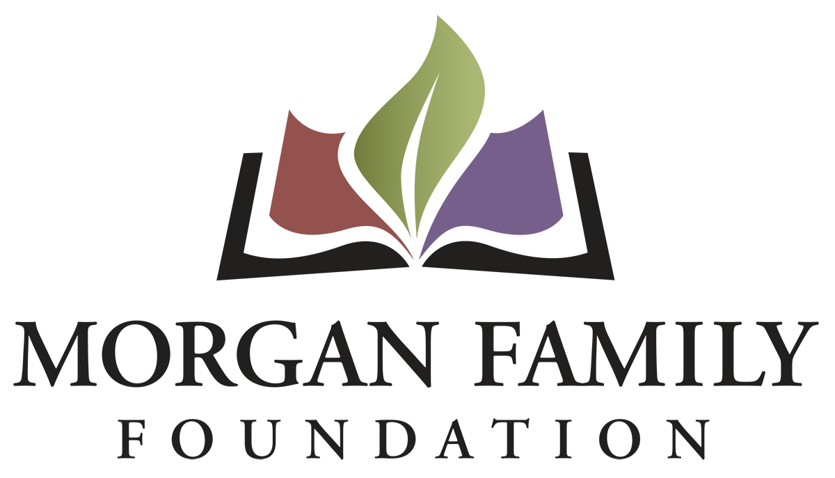
Letter of Inquiry: Social Equity – Required Information for 2024
This document is provided for reference only. Please do not attempt to use this as an application or Letter of Inquiry, which must be submitted online at morganfamilyfdn-portal.givingdata.com/campaign/socialequity.
The following information is required for submission of a Letter of Inquiry (LOI). [Bracketed items] are not required but are requested/optional and may not be applicable for a particular request.
Organization Data
- Full Legal Organization Name
- Employer Tax Identification Number (EIN)
- [Other name, if different (AKA/Also Known As, DBA/Doing Business As, or project name if applicant is utilizing a fiscal sponsor)]
- Address Line 1
- [Address Line 2]
- City, State, Zip, Country
- [Secondary Organization Address]
- [Organization Email Address]
- [Organization Website]
- Organization Phone Number
- [Organization Fax Number]
- Mission/Purpose
- What is your organization’s tax status? 501(c)(3) Public Charity; Public agency/unit of government; Using Fiscal Sponsor; Other/Unsure
- [Full Legal Name of Fiscal Sponsor]
- [EIN of Fiscal Sponsor]
- Total annual organization budget for current fiscal year & fiscal year ending date
Contact Information
- Name of top (paid) staff person [prefix, suffix]
- Title [Department]
- [Pronouns]
- E-mail
- Phone
- Work Address
- Name of contact person regarding this application [prefix, suffix]
- Title [Department]
- [Pronouns]
- E-mail
- Phone
- Work Address
Request Data
- Request Title
- Dollar Amount Requested
- Grant Budget
- Type of support that is being requested (check all that apply): __General operating support __Start-up costs __Capital request __Project/program support __Capacity building __Advocacy __Other
- [If other, briefly describe what is needed]
- Briefly elaborate about the geographic area served by naming the counties, cities, communities, etc. as appropriate that are the focus of your proposed grant.
Narrative Questions (narrative responses required)
- Please give a brief summary of the grant purpose. (Most people write about 2-3 sentences)
- Describe the demographics of the disadvantaged community who will be impacted. Approximately how many people will be served annually?
- About Your Impact: Describe: (1) the unfair disparity that your grant will address; (2) the harm caused by the disparity; (3) what your grant will do to (a) reduce the disparity and (b) make changes in attitudes, practices, or policies to achieve positive outcomes; and (4) how you identified this disparity.
- Briefly describe the positive outcomes for this disadvantaged population if the grant is successful.
- Who will be involved in the development, implementation and evaluation of this grant?
- Please provide more detail about the implementation steps and timetable if you receive this funding.
  - Grant start date (MM/DD/YYYY)
  - Grant end date (MM/DD/YYYY)
- Use and amount of funds requested, i.e., staff costs, consultant fees, materials, etc. Please list below and/or upload an expense budget with detail.
- Please provide three specific measurable outcomes for your proposal. Identify which outcomes connect specifically to the inequity your proposal addresses.

[Organization’s Demographic Data: The system will display the information currently shared about your organization’s demographics on Candid. We do not currently require this information; however, we strongly encourage you to keep this information completed and up-to-date.]
Authorization: The system will prompt the top paid staff or board chair to type their name, title, and date, certifying authorization to submit this letter of inquiry on behalf of the organization, and that, to the best of their knowledge, the information contained therein is true, accurate, and complete.

