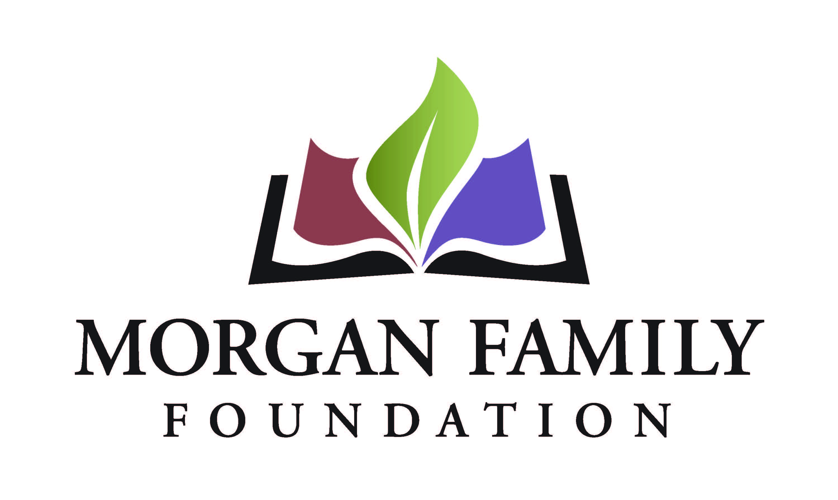
Full Grant Application: Social Equity - Required Information for 2022
When invited to submit a full grant application, you will have the opportunity to review and update the “fill-in-the blank” information submitted as part of your Letter of Inquiry. In addition, the following information is required for submission of a Full Grant Application. [Bracketed items] are not required, but are requested/optional and may not be applicable for a particular request.
Organization Narrative Information
- Briefly summarize the organization’s history. Include any information about diversity, inclusion or equity with which the organization is currently/has been involved.
- Please provide a summary of the organization’s goals. Please point out any that have specific reference to diversity, inclusion or equity.
- Briefly description current programs and activities. Highlight those with a diversity, inclusion or equity component.
- Please provide a brief description of recent accomplishments, especially those that advance diversity, inclusion or equity.
- What is the applicant’s relationship with other organizations working with similar missions? What is your role relative to these other organizations?
- Please provide the number and demographics of board members, paid staff (full-time and part-time) and volunteers.

Purpose of Grant
- Describe the unfair disparity that your grant will address, the harm caused by the disparity, and what your grant will do to (1) reduce the disparity and (2) make changes in attitudes, practices, or policies to achieve positive outcomes. How did you identify this disparity?
- Review and update, as needed, the three measurable objectives previously provided. Identify the specific activities you will use to achieve each of those objectives.
- Describe the community who will benefit if your grant is successful. Include how many are involved and the demographic characteristics relevant to the grant. If the grant is successful, describe the positive outcomes for this community.
- Describe how you will know that your objectives have been achieved. How will you assess this and what methods and tools will you use to capture data to evaluate this grant?
- Identify other organizations, if any, participating in the project. If applicable, provide summary descriptions of any inequity reduction work in which those organizations have been involved related to this project.
- Summarize plans for continuation of the project after the grant.
- Please provide more detail about the implementation steps and timetable if you receive this funding.
- Grant start date (MM/DD/YYYY)
- Grant end date (MM/DD/YYYY)
- Suggested interim grant report due date (MM/DD/YYYY)
- Suggested final grant report due date (MM/DD/YYYY – typically due ~1 month after grant end date)
- [Is there anything else you want to tell us related to this grant request? Please describe below or upload an attachment.]
Attachments
- Finances
  - Financial statement from most recently completed fiscal year, audited if available, showing actual expenses. This information should include a statement of financial position, statement of revenue and expense, and statement of activities (functional expenses).
  - Organization’s budget for current year, including income and expenses.
  - [Project budget, including income and expenses (if not a general operating proposal).]
  - [Additional funders. List names of corporations, foundations or any other sources from which you are requesting funds for this project, with dollar amounts, indicating which sources are committed or pending.]
- List of board members and their affiliations.
- [To be completed only if applicant is serving as a fiscal sponsor for this request:
  - List of the project’s leadership and advisory committee members and their affiliations.
  - Written agreement between the fiscal sponsor/applicant organization and the project and, if not explicit in the agreement, a letter stating that the sponsor accepts full legal, fiscal, and programmatic responsibility for the project.]

- Authorized by: The system will prompt the top paid staff or board chair to type their name, title, and date, certifying authorization to submit this letter of inquiry on behalf of the organization, and that, to the best of your knowledge, the information contained is true, accurate, and complete.

