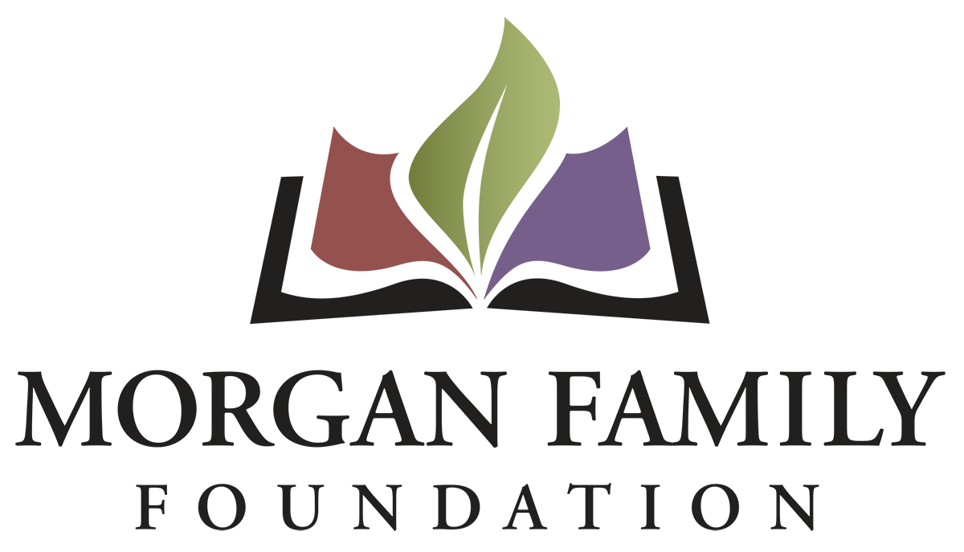
End of Life Final Report: Information Required

The purpose of this form is to build consistency in how grantee partners report on their results and learnings, as well as to monitor progress on end-of-life issues in central Minnesota. Your candid responses will help us better reflect on the impact of your work and our grantmaking.

Please respond to the questions below in our GivingData portal. Concise answers are appreciated, and in most cases, 1-3 paragraphs should be sufficient for a narrative response to a question. However, there is no penalty for exceeding that length if you deem appropriate.

If you have any questions or would like to add a collaborator to your application, please email the Foundation office at info@morganfamilyfdn.org.

Outcomes & Impact

- Measurable Outcomes: Review and reflect on the outcomes provided in your original grant application. Describe the progress you made on each outcome, the data you have to demonstrate the progress, and how you gathered that data. If your outcomes evolved or differ from your proposal, please explain and elaborate on the outcomes you did have.

- Impact and Engagement: Please describe the individuals, organizations, or communities your work impacted or engaged. Include any data or statistics you collected that help illustrate this.

Reflections

- Opportunities and Challenges: Please describe how any unanticipated opportunities and/or challenges you encountered affected implementation of your work.

- Learnings: As you reflect on your efforts, please describe three significant takeaways which will impact your work going forward.

- Illustrating Your Impact, Work, and Community Partners: You are strongly encouraged to attach media (or email large files separately) to illustrate your activity and the people you engaged, for example, 3-5 slides, social media posts, photos, or a video no longer than 5 minutes discussing and/or illustrating the impact and importance of your work. These will be used to directly engage our board or on our website (with your permission) to share the importance and impact of work supported by the foundation.

Financial Reporting

- Budget: Using the final budget approved for your proposal, provide an itemized account of actual expenses and income for this period. Provide narrative on any variances of 10% or greater from the approved grant budget.

- Additional Funding: Who else has provided funding to you for this work, and at what level?

Certification

The system will prompt you to type your name, title, and date, certifying that you are duly authorized to submit this report on behalf of the organization, and to the best of your knowledge the information contained herein is true, accurate and complete.

Feedback Requested

(Optional) We seek your help in our efforts to streamline our processes. Please estimate the total amount of time it took your organization to complete this report.

