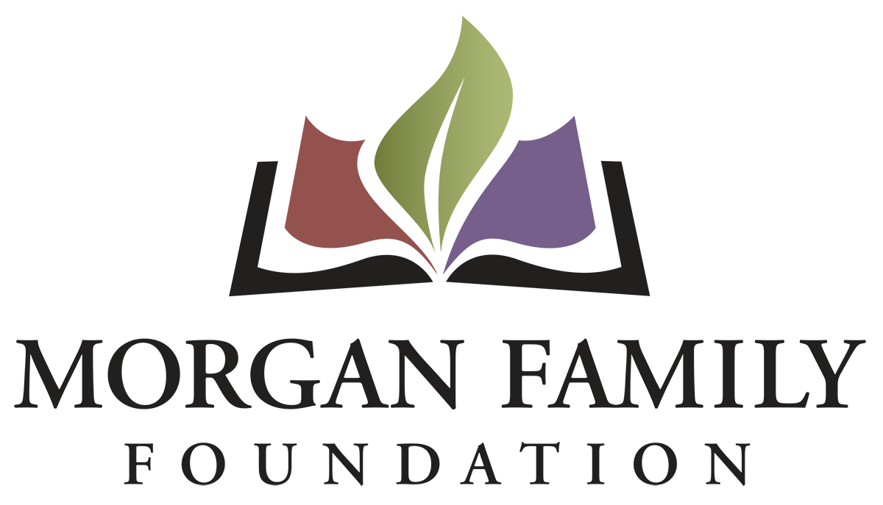
Letter of Inquiry: Social Equity – Required Information for 2022
This document is provided for reference only. Please do not attempt to use this as an application or Letter of Inquiry, which must be submitted online at morganfamilyfdn-portal.givingdata.com/campaign/socialequity.
The following information is required for submission of a Letter of Inquiry (LOI). [Bracketed items] are not required but are requested/optional and may not be applicable for a particular request.
Organization Information
- Legal name of organization
- Applicant organization’s employer identification number (EIN)
- [Other name, if different (AKA/Also Known As, DBA/Doing Business As, or project name if applicant is serving as a fiscal sponsor)]
- Address Line 1
- [Address Line 2]
- City, State, Zip
- [Secondary Organization Address]
- [Organization Email Address]
- [Organization Website]
- Organization Phone Number
- [Organization Fax Number]
- Is this organization an IRS 501(c)(3) public charity? Yes/No
- If not a 501(c)(3), is this organization a public agency/unit of government? Yes/No
- Please give a 2-3 sentence summary of the organization’s purpose and/or its mission statement.
- Total annual organization budget for current fiscal year & fiscal year ending date
Contact Information
- Name of top (paid) staff person [prefix, suffix]
- Title [Department]
- [Pronouns]
- Phone
- E-mail
- Work Address
- Name of contact person regarding this application [prefix, suffix]
- Title [Department]
- [Pronouns]
- Phone
- E-mail
- Work Address

Proposal Summary
- Grant/Project Title
- Please give a brief summary of the grant purpose.
- What states will benefit from the proposed grant (select all that apply): __MN __Other
- Briefly elaborate about the geographic area served. Be more specific than the state(s) checked above by naming the counties, cities, communities, etc. as appropriate that are the focus of your proposed grant.
- What are grant funds being requested for (check all that apply): __General operating support __Start-up costs __Capital __Project/program support __Capacity building __Advocacy __Other (If other, briefly describe what is needed)
- Requested Grant Amount
- Grant Budget
Brief Narrative (narrative responses required)
- Briefly describe the unfair disparity your grant will address and the harm caused to the community involved.
- Briefly describe what your proposal will do to: (1) reduce the disparity and (2) make changes in attitudes, practices, or policies leading to positive outcomes.
- Describe the demographics of the disadvantaged community who will be impacted. Approximately how many people will be served annually?
- Briefly describe the positive outcomes for this disadvantaged population if the grant is successful.
- Who will be involved in development, implementation and evaluation of this grant?
- Grant start date (MM/DD/YYYY)
- Grant end date (MM/DD/YYYY)
- Please provide more detail about the implementation steps and timetable if you receive this funding.
- Use and amount of funds requested, i.e., staff costs, consultant fees, materials, etc. Please list below and/or upload an expense budget with detail.
- Please provide three specific measurable outcomes for your proposal. Identify which outcomes connect specifically to the inequity your proposal addresses.
- Authorized by: The system will prompt the top paid staff or board chair to type their name, title, and date, certifying authorization to submit this letter of inquiry on behalf of the organization, and that, to the best of your knowledge, the information contained is true, accurate, and complete.

