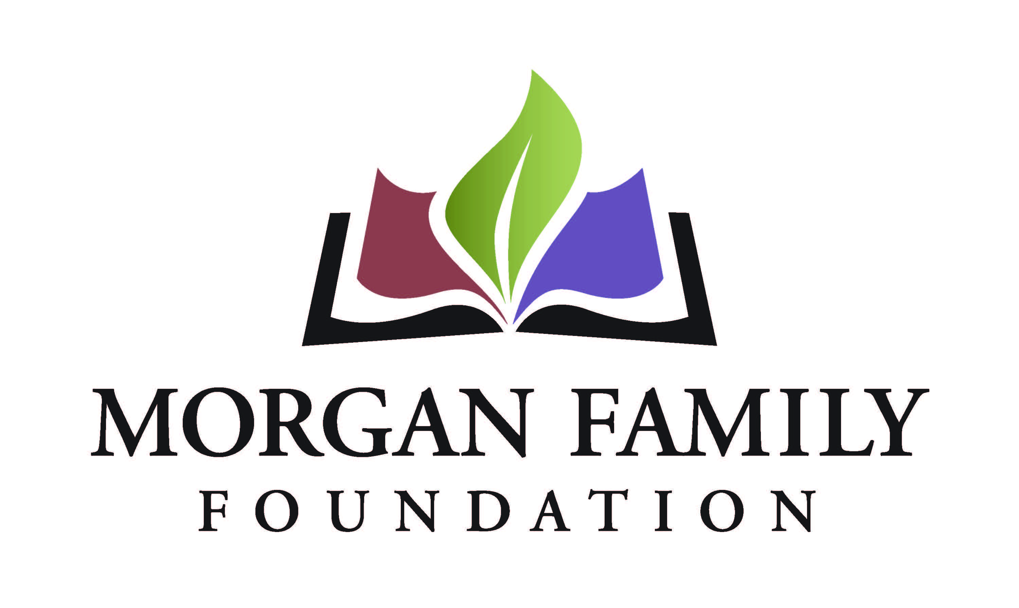
Letter of Inquiry: End of Life – Required Information for Summer/Fall 2021
This document is provided for reference only. Please do not attempt to use this as an application or Letter of Inquiry, which must be submitted online at https://morganfamilyfdn.egrant.net .
The following information is required for submission of a Letter of Inquiry (LOI). [Bracketed items] are not required, but are requested/optional and may not be applicable for a particular request.
Organization Information
- Applicant organization’s employer identification number (EIN)
- Legal name of organization
- [Other name, if different (DBA/Doing Business As or project name if applicant is serving as a fiscal sponsor)]
- Address Line 1
- [Address Line 2]
- City, State, Zip+4 (there is a look-up for +4 code within our online application system)
- Phone number
- [Fax number]
- [Web site]
- Name of top (paid) staff person
- Title
- Phone
- E-mail
- Is this organization an IRS 501(c)(3) public charity? Yes/No
- If not a 501(c)(3), is this organization a public agency/unit of government? Yes/No/Not Applicable
- Please give a 2-3 sentence summary of the organization’s purpose (600 Character Limit)
Proposal Information
- Grant/Project Title
- Name of contact person regarding this application
- Title
- Phone
- E-mail
- Please give a 2-3 sentence summary of the grant purpose (1,000 Character Limit)
- Geographic area served classification (check all that apply): __MN __ OH __Other (list)___________________________________________
- Briefly elaborate about the geographic area served
- Funds are being requested for (check all that apply): __General operating support __Start-up costs __Capital __Project/program support __Technical assistance __Advocacy __Other (list)_______
- Request/project start date (MM/DD/YYYY)
- Request/project end date (MM/DD/YYYY)
Budget
- Dollar amount requested
- Total annual organization budget
- [For requests other than general operating support, what is the total project budget?]
- Attachment: Organization’s budget for current year, including income and expenses
- Attachment: Financial states from the most recently completed fiscal year, audited if available, showing actual expenses. This should include a statement of financial position, statement of revenue and expense, and statement of activities.
Proposal Summary (narrative responses required)
- Please summarize the need/issue/opportunity your proposal addresses and briefly describe what your proposal will do to address it. (1,500 Character Limit)
- What is the major goal you hope to address with this proposal? (500 Character Limit)
- Who will be involved? (500 Character Limit)
- Describe the people who will be impacted and briefly explain how they will be impacted. (500 Character Limit)
- How will the project be implemented? (500 Character Limit)
- What is your organization’s capacity to implement your proposal (volunteers, partnerships, reputation, finances, etc.)? (750 Character Limit)
- Please provide more detail about when the proposal will begin and end. (400 Character Limit)
- Use and amount of funds requested, i.e., staff costs, consultant fees, materials, etc. Please list below and/or upload an expense budget with detail. (350 Character Limit)
- Please provide three specific measurable outcomes for your proposal. (500 Character Limit)
- Authorized by: The system will prompt the top paid staff or board chair to type their name, title, and date, certifying authorization to submit this letter of inquiry on behalf of the organization, and that, to the best of your knowledge, the information contained is true, accurate, and complete.

