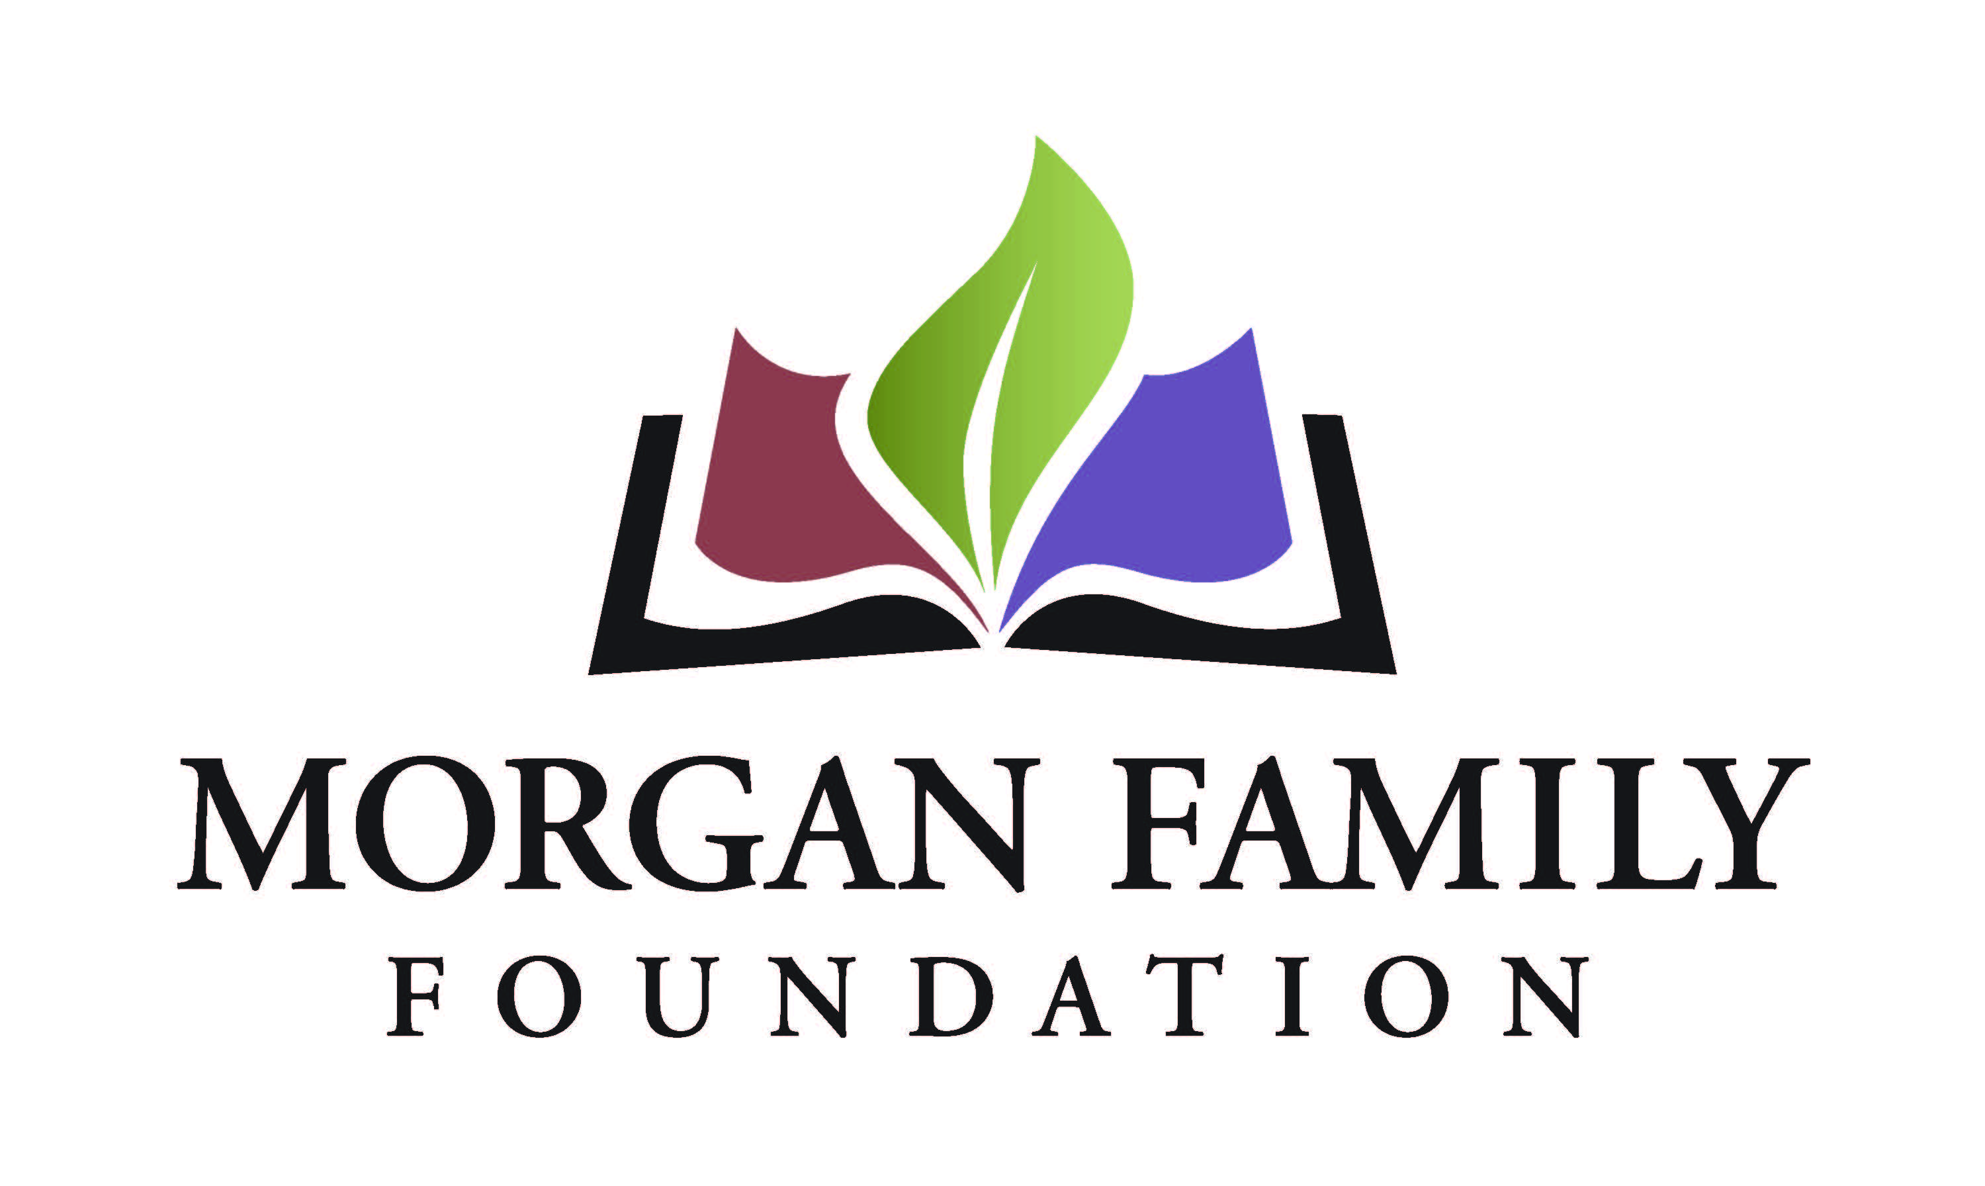
Letter of Inquiry: Global Warming in Minnesota – Required Information for 2021
This document is provided for reference only. Please do not attempt to use this as an application or Letter of Inquiry, which is by invitation only and must be submitted online at http://morganfamilyfdn.egrant.net .
The following information is required for submission of a Letter of Inquiry (LOI). [Bracketed items] are not required but are requested/optional and may not be applicable for a particular request.
Organization Information
- Applicant organization’s employer identification number (EIN)
- Legal name of organization
- [Other name, if different (DBA/Doing Business As or project name if applicant is serving as a fiscal sponsor)]
- Address Line 1
- [Address Line 2]
- City, State, Zip+4 (there is a look-up for +4 code within our online application system)
- Phone number
- [Fax number]
- [Web site]
- Name of top (paid) staff person
- Title
- Phone
- E-mail
- Is this organization an IRS 501(c)(3) public charity? Yes/No
- If not a 501(c)(3), is this organization a public agency/unit of government? Yes/No/Not Applicable
- Please give a 2-3 sentence summary of the organization’s purpose (600 Character Limit)
Proposal Information
- Grant/Project Title
- Name of contact person regarding this application
- Title
- Phone
- E-mail
- Please give a 2-3 sentence summary of the grant purpose (1,000 Character Limit)
- Geographic area served classification (check all that apply): __MN __ OH __Other (list)___________________________________________
- Briefly elaborate about the geographic area served
- Funds are being requested for (check all that apply): __General operating support __Start-up costs __Capital __Project/program support __Technical assistance __Advocacy __Other (list)________
- Request start date (MM/DD/YYYY)
- Request end date (MM/DD/YYYY)

Budget
- Dollar amount requested
- Total annual organization budget
- [For requests other than general operating support, what is the total project budget?]
- Attachments:
  - Organization’s budget for current year, including income and expenses
  - Financial statement from most recently completed fiscal year, audited if available, showing actual expenses. This information should include a statement of financial position, statement of revenue and expense, and statement of activities (functional expenses).

Proposal Summary (narrative responses required)
- What part of mitigating global warming in Minnesota do you propose to address? Briefly describe what your proposal will do to address this. (2,000 Character Limit)
- What region, community, or demographic in Minnesota will this work serve? Please elaborate on the importance of this. (750 Character Limit)
- Who will be involved in development, implementation, and evaluation of the grant? Describe your relationship to the region, partners, communities, and organizations that you will work with. (750 Character Limit)
- Describe how this work will result in broadening the demographics of Minnesotans engaged in mitigating global warming, increase understanding of global warming in Minnesota, or support technologies or actions that mitigate the impacts of global warming. (750 Character Limit)
- Briefly describe how this work builds on past work done by your organization and other organizations. (750 Character Limit)
- What is your organization’s capacity to implement your proposal (volunteers, partnerships, reputation, finances, etc.)? (750 Character Limit)
- Please provide more detail about when the grant activities will begin and end if you receive this funding. (750 Character Limit)
- Use and amount of funds requested, i.e., staff costs, consultant fees, materials, etc. Please list below and/or upload an expense budget with detail. (350 Character Limit)
- Please provide three specific measurable outcomes for your proposal. (750 Character Limit)
- Authorized by: The system will prompt you to enter the name and title of the top paid staff or board chair, certifying that you are duly authorized to submit this grant request on behalf of the organization, and to the best of your knowledge the information contained herein is true, accurate and complete.

