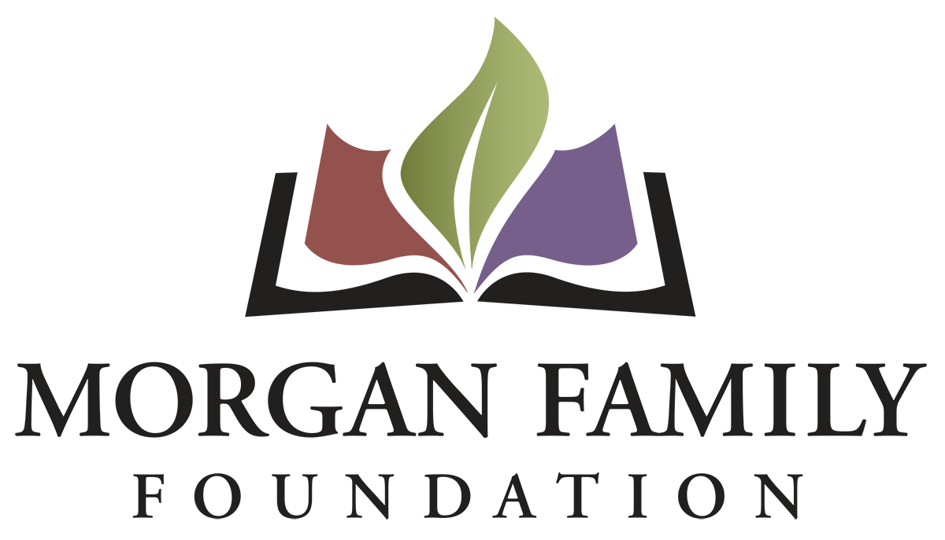
Letter of Inquiry: Global Warming in Minnesota Renewals – Required Information for Summer/Fall 2021
This document is provided for reference only. Please do not attempt to use this as an application or Letter of Inquiry, which is by invitation only and must be submitted online at http://morganfamilyfdn.egrant.net .
The following information is required for submission of a Letter of Inquiry (LOI). [Bracketed items] are not required but are requested/optional and may not be applicable for a particular request.
Organization Information
- Applicant organization’s employer identification number (EIN)
- Legal name of organization
- [Other name, if different (DBA/Doing Business As or project name if applicant is serving as a fiscal sponsor)]
- Address Line 1
- [Address Line 2]
- City, State, Zip+4 (there is a look-up for +4 code within our online application system)
- Phone number
- [Fax number]
- [Web site]
- Name of top (paid) staff person
- Title
- Phone
- E-mail
- Is this organization an IRS 501(c)(3) public charity? Yes/No
- If not a 501(c)(3), is this organization a public agency/unit of government? Yes/No/Not Applicable
- Please give a 2-3 sentence summary of the organization’s purpose (600 Character Limit)
Proposal Information
- Grant/Project Title
- Name of contact person regarding this application
- Title
- Phone
- E-mail
- Please give a 2-3 sentence summary of the grant purpose (1,000 Character Limit)
- Geographic area served classification (check all that apply): __MN __ OH __Other (list)___________________________________________
- Briefly elaborate about the geographic area served
- Funds are being requested for (check all that apply): __General operating support __Start-up costs __Capital __Project/program support __Technical assistance __Advocacy __Other (list)________
- Request start date (MM/DD/YYYY)
- Request end date (MM/DD/YYYY)

Budget
- Dollar amount requested
- Total annual organization budget
- [For requests other than general operating support, what is the total project budget?]
- Attachments:
  - Organization’s budget for current year, including income and expenses
  - Financial statement from most recently completed fiscal year, audited if available, showing actual expenses. This information should include a statement of financial position, statement of revenue and expense, and statement of activities (functional expenses).

Proposal Summary (narrative responses required)
- Briefly describe how your proposal to renew grant funding builds on the work you did in the previous year to address global warming. (2,000 Character Limit)
- Will the work serve the same region, community, or demographic in Minnesota? Please elaborate on any significant differences. (750 Character Limit)
- Will the work involve the same partners, communities, and organizations that you worked with in the previous year? Please elaborate on significant differences in the composition or roles. (750 Character Limit)
- Have there been any significant changes in your organization’s capacity to implement your proposal (volunteers, partnerships, reputation, finances, etc.)? (750 Character Limit)
- Use and amount of funds requested, i.e., staff costs, consultant fees, materials, etc. Please list below and/or upload an expense budget with detail. (750 Character Limit)
- Please provide three specific measurable outcomes you will achieve with an additional year of funding. (750 Character Limit)
- Authorized by: The system will prompt you to enter the name and title of the top paid staff or board chair, certifying that you are duly authorized to submit this grant request on behalf of the organization, and to the best of your knowledge the information contained herein is true, accurate and complete.

