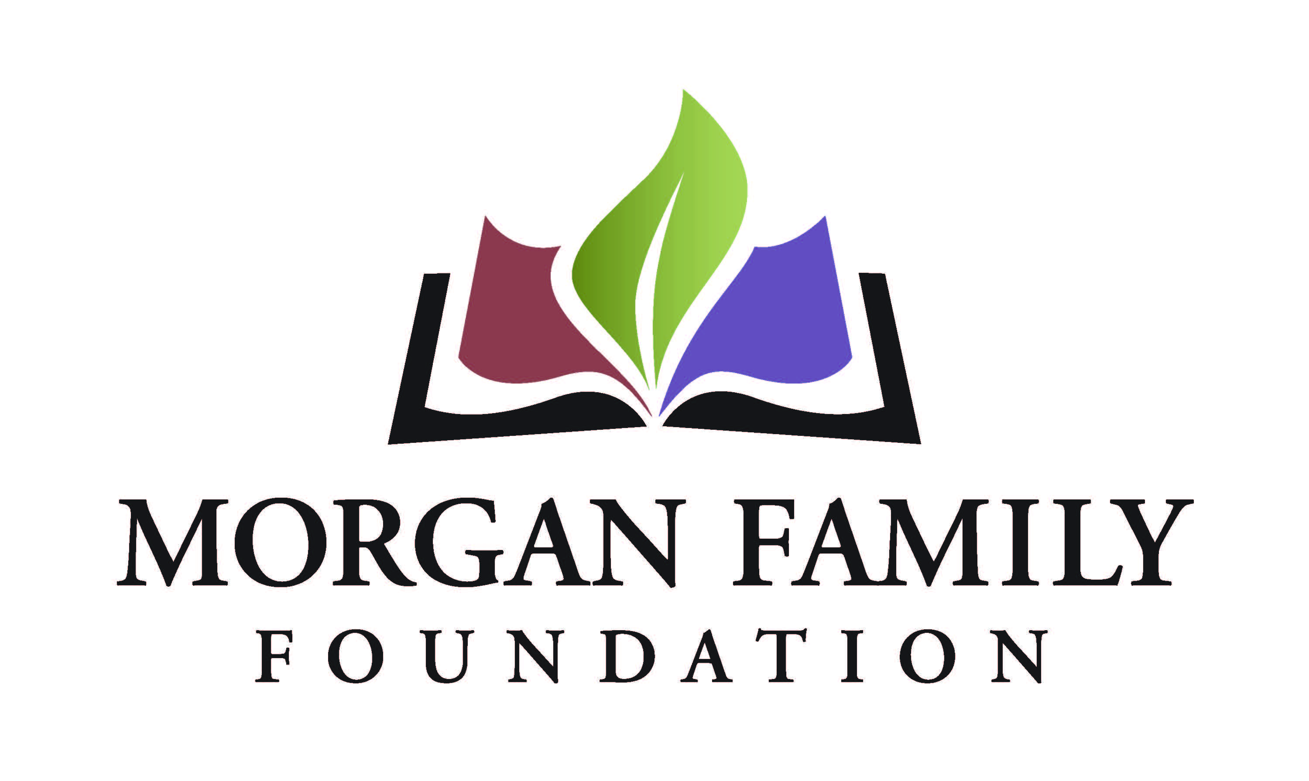
Letter of Inquiry: Social Equity – Required Information for 2021
This document is provided for reference only. Please do not attempt to use this as an application or Letter of Inquiry, which must be submitted online at http://morganfamilyfdn.egrant.net .
The following information is required for submission of a Letter of Inquiry (LOI). [Bracketed items] are not required, but are requested/optional and may not be applicable for a particular request.
Organization Information
- Applicant organization’s employer identification number (EIN)
- Legal name of organization
- [Other name, if different (DBA/Doing Business As or project name if applicant is serving as a fiscal sponsor)]
- Address Line 1
- [Address Line 2]
- City, State, Zip+4 (there is a look-up for +4 code within our online application system)
- Phone number
- [Fax number]
- [Web site]
- Name of top (paid) staff person
- Title
- Phone
- E-mail
- Is this organization an IRS 501(c)(3) public charity? Yes/No
- If not a 501(c)(3), is this organization a public agency/unit of government? Yes/No/Not Applicable
- Please give a 2-3 sentence summary of the organization’s purpose (600 Character Limit)
Proposal Information
- Grant/Project Title
- Name of contact person regarding this application
- Title
- Phone
- E-mail
- Please give a brief summary of the grant purpose. (1,000 Character Limit)
- Geographic area served classification (check all that apply): __MN __OH __Other (list)___________________________________________
- Briefly elaborate about the geographic area served
- Funds are being requested for (check all that apply): __General operating support __Start-up costs __Capital __Project/program support __Technical assistance __Advocacy __Other (list)________
- Request start date (MM/DD/YYYY)
- Request end date (MM/DD/YYYY)
Budget
- Dollar amount requested
- Total annual organization budget
- [For requests other than general operating support, what is the total project budget?]
Proposal Summary (narrative responses required)
- Briefly describe the unfair disparity your grant will address and the harm caused to the community involved. (1,000 Character Limit)
- Briefly describe what your proposal will do to: (1) reduce the disparity and (2) make changes in attitudes, practices, or policies leading to positive outcomes. (750 Character Limit)
- Describe the demographics of the disadvantaged community who will be impacted. Approximately how many people will be served annually? (750 Character Limit)
- Briefly describe the positive outcomes for this disadvantaged population if the grant is successful. (500 Character Limit)
- Who will be involved in development, implementation and evaluation of this grant? (500 Character Limit)
- Summarize the steps in the implementation plan for the grant. (750 Character Limit)
- Please provide more detail about when the grant activities will begin and end if you receive this funding. (400 Character Limit)
- Use and amount of funds requested, i.e., staff costs, consultant fees, materials, etc. Please list below and/or upload an expense budget with detail. (350 Character Limit)
- Please provide three specific measurable objectives for your proposal. Identify which objectives connect specifically to the inequity your proposal addresses. (1,500 Character Limit)
- Authorized by: The system will prompt the top paid staff or board chair to type their name, title, and date, certifying authorization to submit this letter of inquiry on behalf of the organization, and that, to the best of your knowledge, the information contained is true, accurate, and complete.

