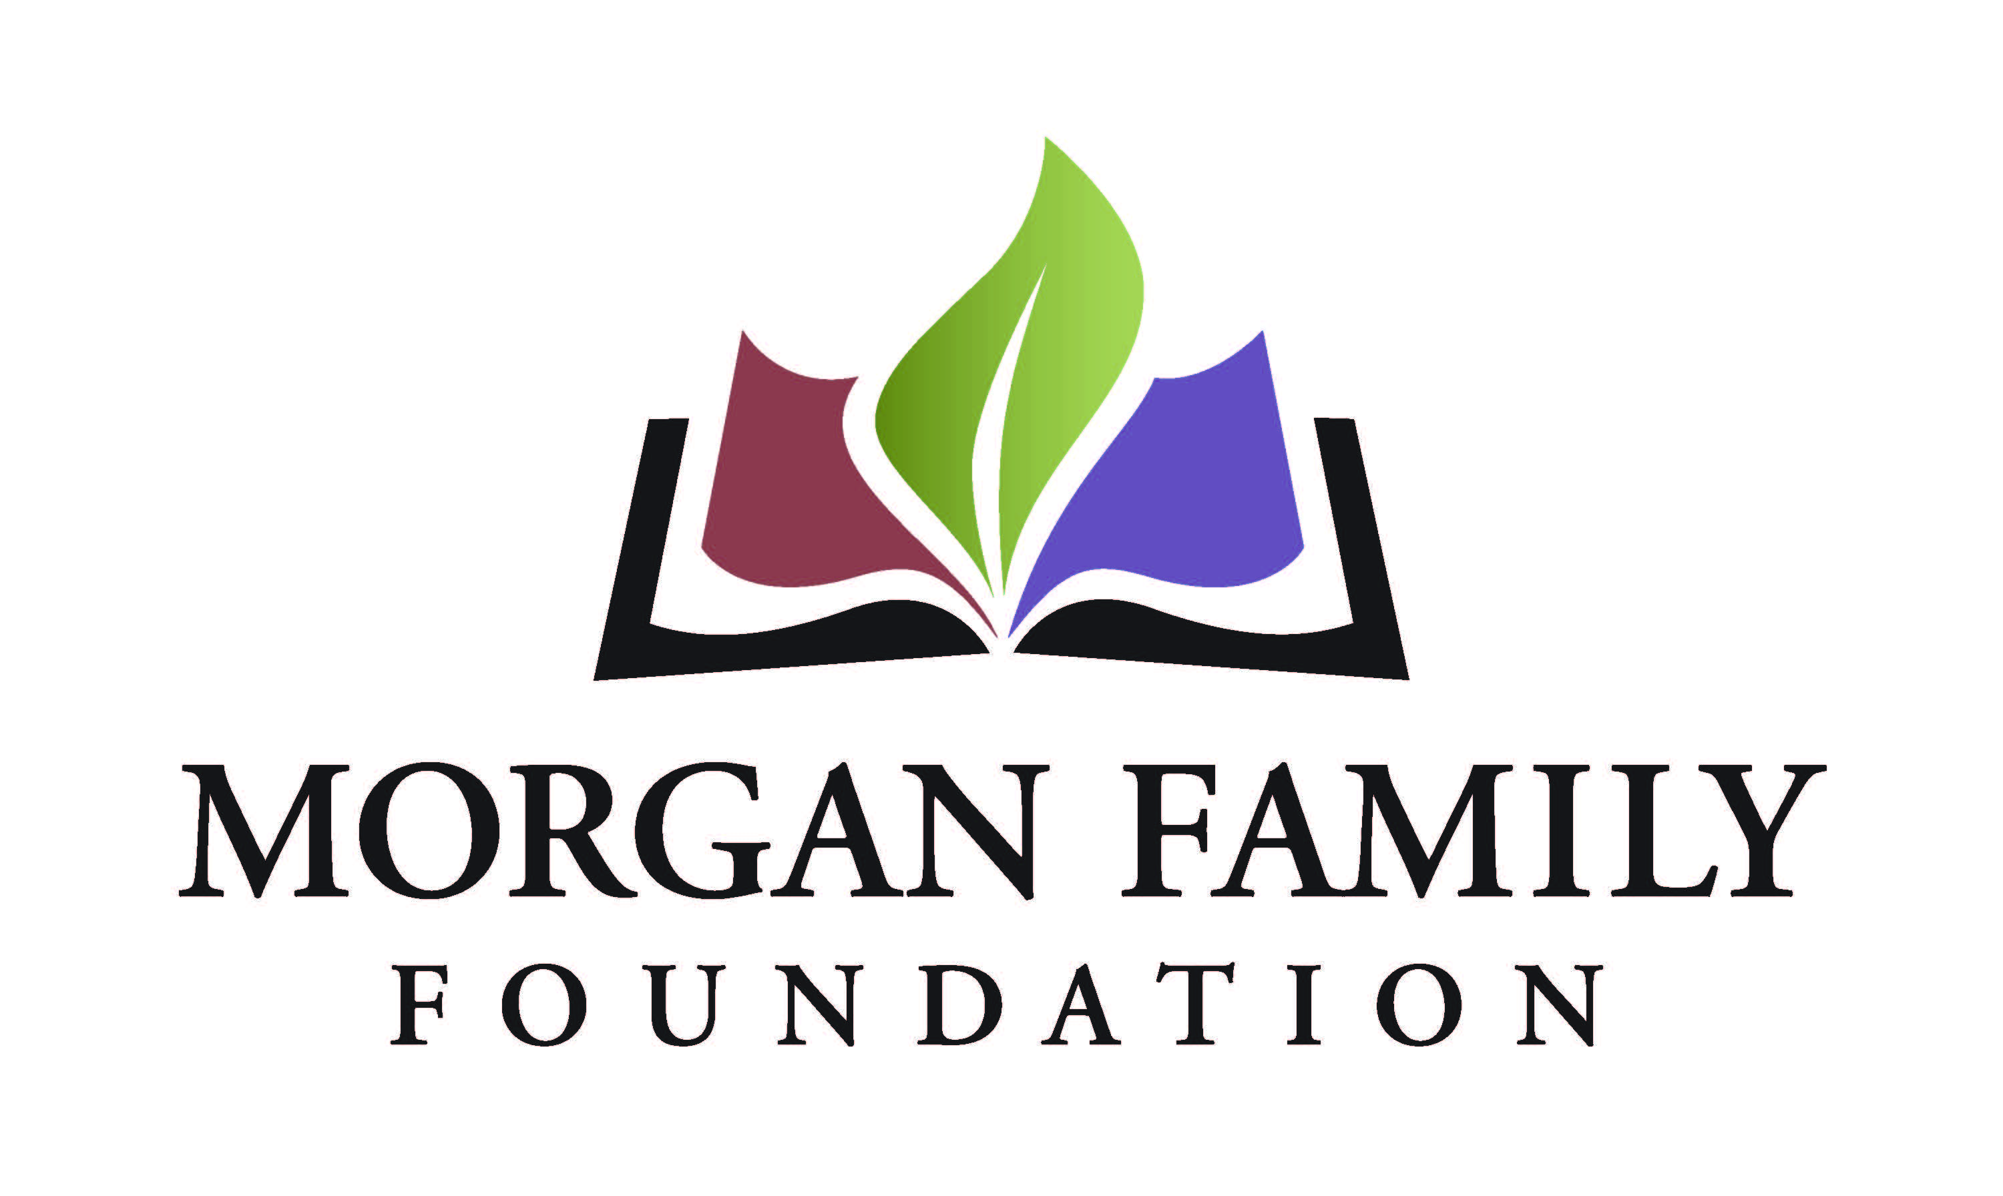
Grantee Interim Report Form

The purpose of this reporting format is to monitor the progress of grantees and build greater consistency in how grantees report on their learning and accomplishments. Your candid responses will help us better reflect on the impact of your work and our grantmaking.

Please complete the form and provide your responses, either by inserting your text or attaching additional pages. Please limit your narrative responses (Section III) to a maximum of three (3) pages.

I. Grant Information
Organization Name
Grant Title
Date of Grant Amount of Grant

II. Certification & Contact Information

By typing my name, title and date below, I certify that I am duly authorized to submit this report on behalf of the organization, and to the best of my knowledge the information contained herein is true, accurate and complete.
Name Title _____
Date Phone Email

III. Reflection
- Describe the progress you have made towards achieving the original goal(s) of your grant thus far, including indicators of outcomes cited in your application. You may include progress/impact on your organization, community, and population served.
- Describe unanticipated challenges or benefits that you have encountered to date.
- Describe any plans or changes to address unanticipated challenges or benefits encountered.

