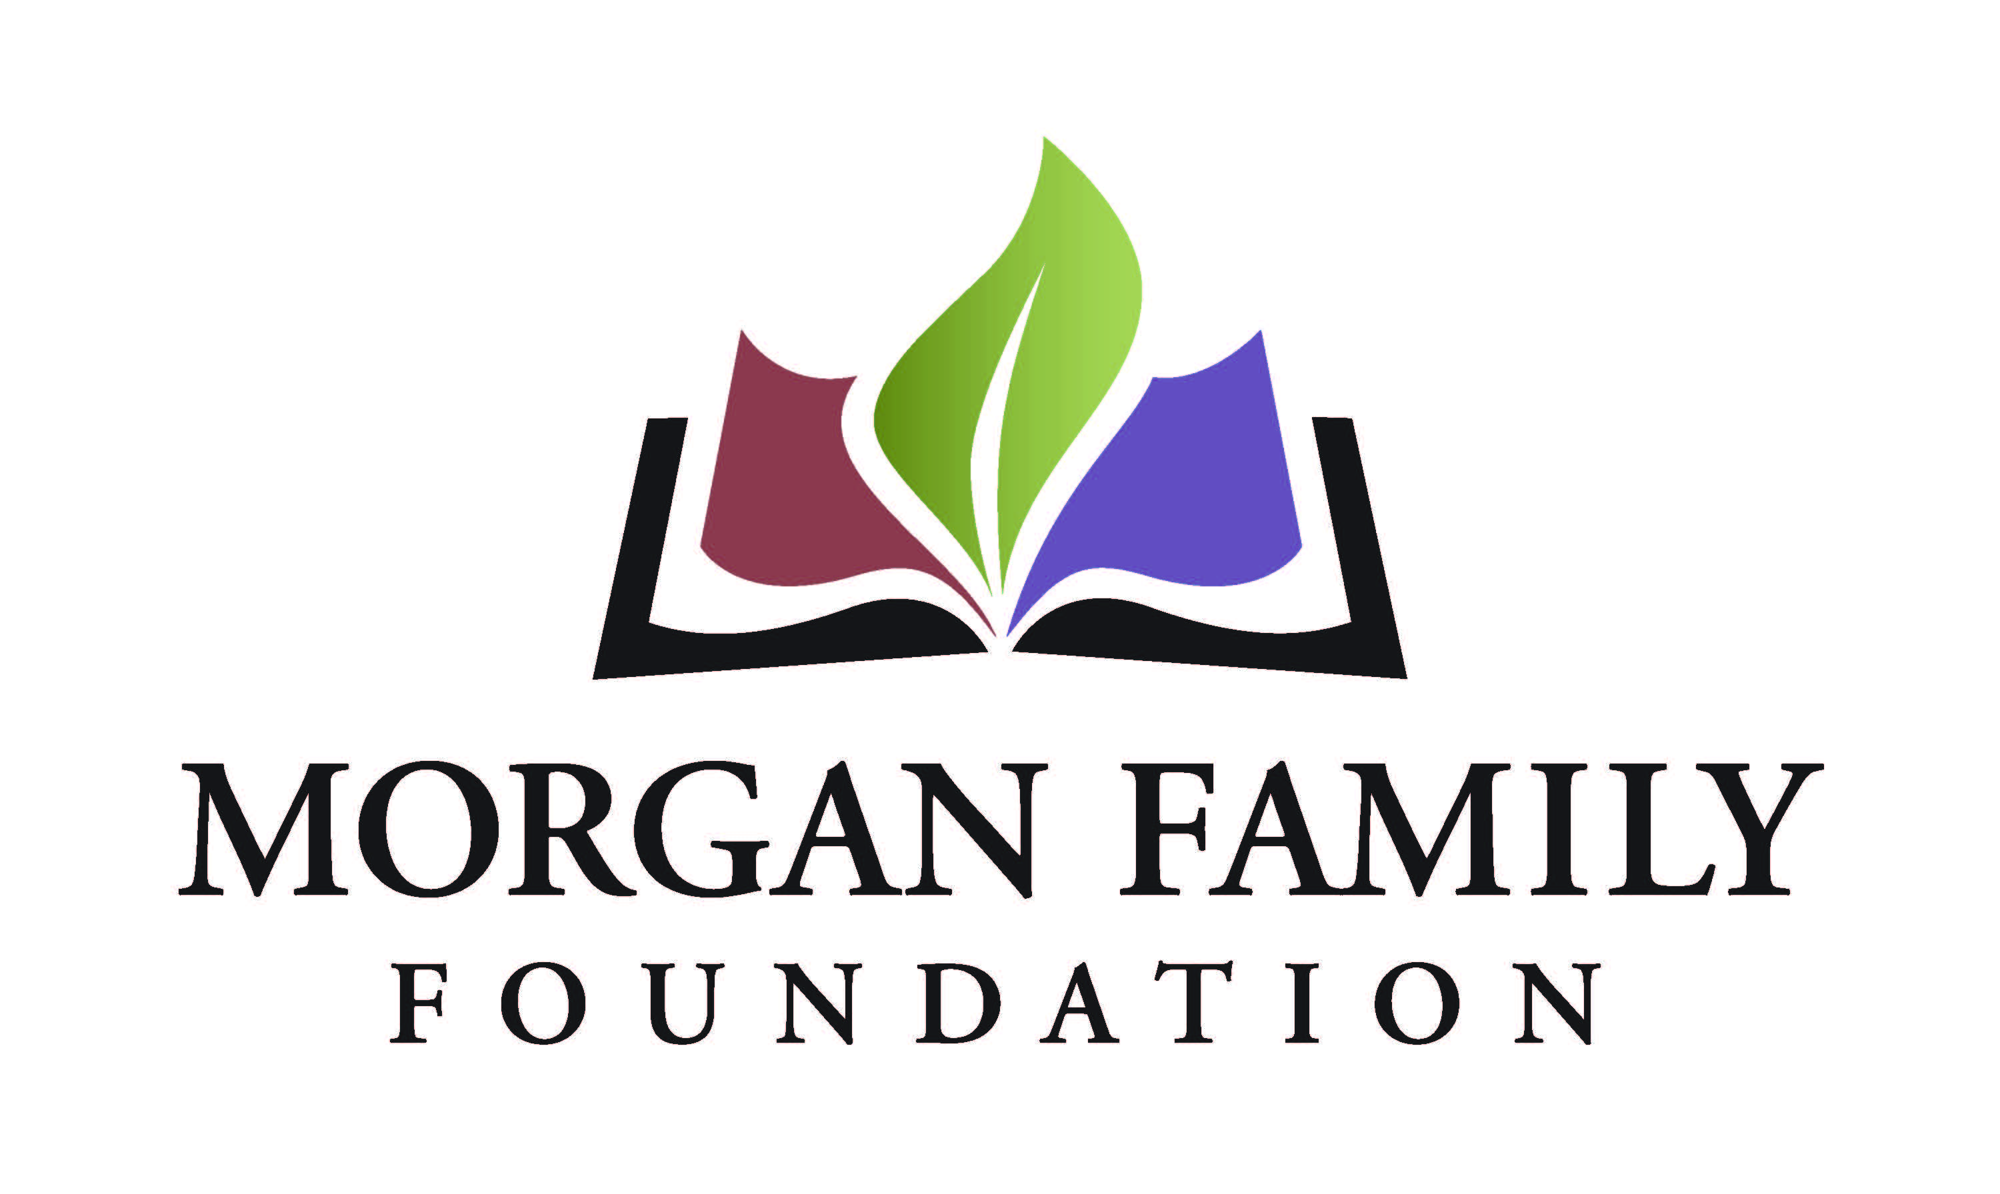
St. Cloud Early Childhood Initiative
Grantee Interim Report Form (Narrative and Financial)

The purpose of this reporting format is to monitor the progress of grantees and build greater consistency in how grantees report on their learning and accomplishments. Your candid responses will help us better reflect on the impact of your work and our grantmaking.

Please complete the form and provide your responses, either by inserting your text or attaching additional pages. Please limit your narrative responses (Section III) to a maximum of three (3) pages.

Attach the financial information as specified in Section IV. If you have any questions, please contact us.

I. Grant Information
Organization Name
Grant Title
Date of Grant Amount of Grant

II. Certification & Contact Information

By typing my name, title and date below, I certify that I am duly authorized to submit this report on behalf of the organization, and to the best of my knowledge the information contained herein is true, accurate and complete.
Name Title _____
Date Phone Email

III. Reflection
- Describe the progress you have made towards achieving the original goals of your grant thus far, including evaluation against the measurable objectives cited in your application. You may include progress/impact on your organization, community, and population served.
- Describe unanticipated challenges or benefits that you have encountered to date.
- Describe any plans or changes to address unanticipated challenges or benefits encountered.

IV. Financial Reporting
- Using the original budget included with your proposal, provide an itemized account of actual expenses and income for this period. Provide narrative on any variances of 10% or greater from the original project budget.

