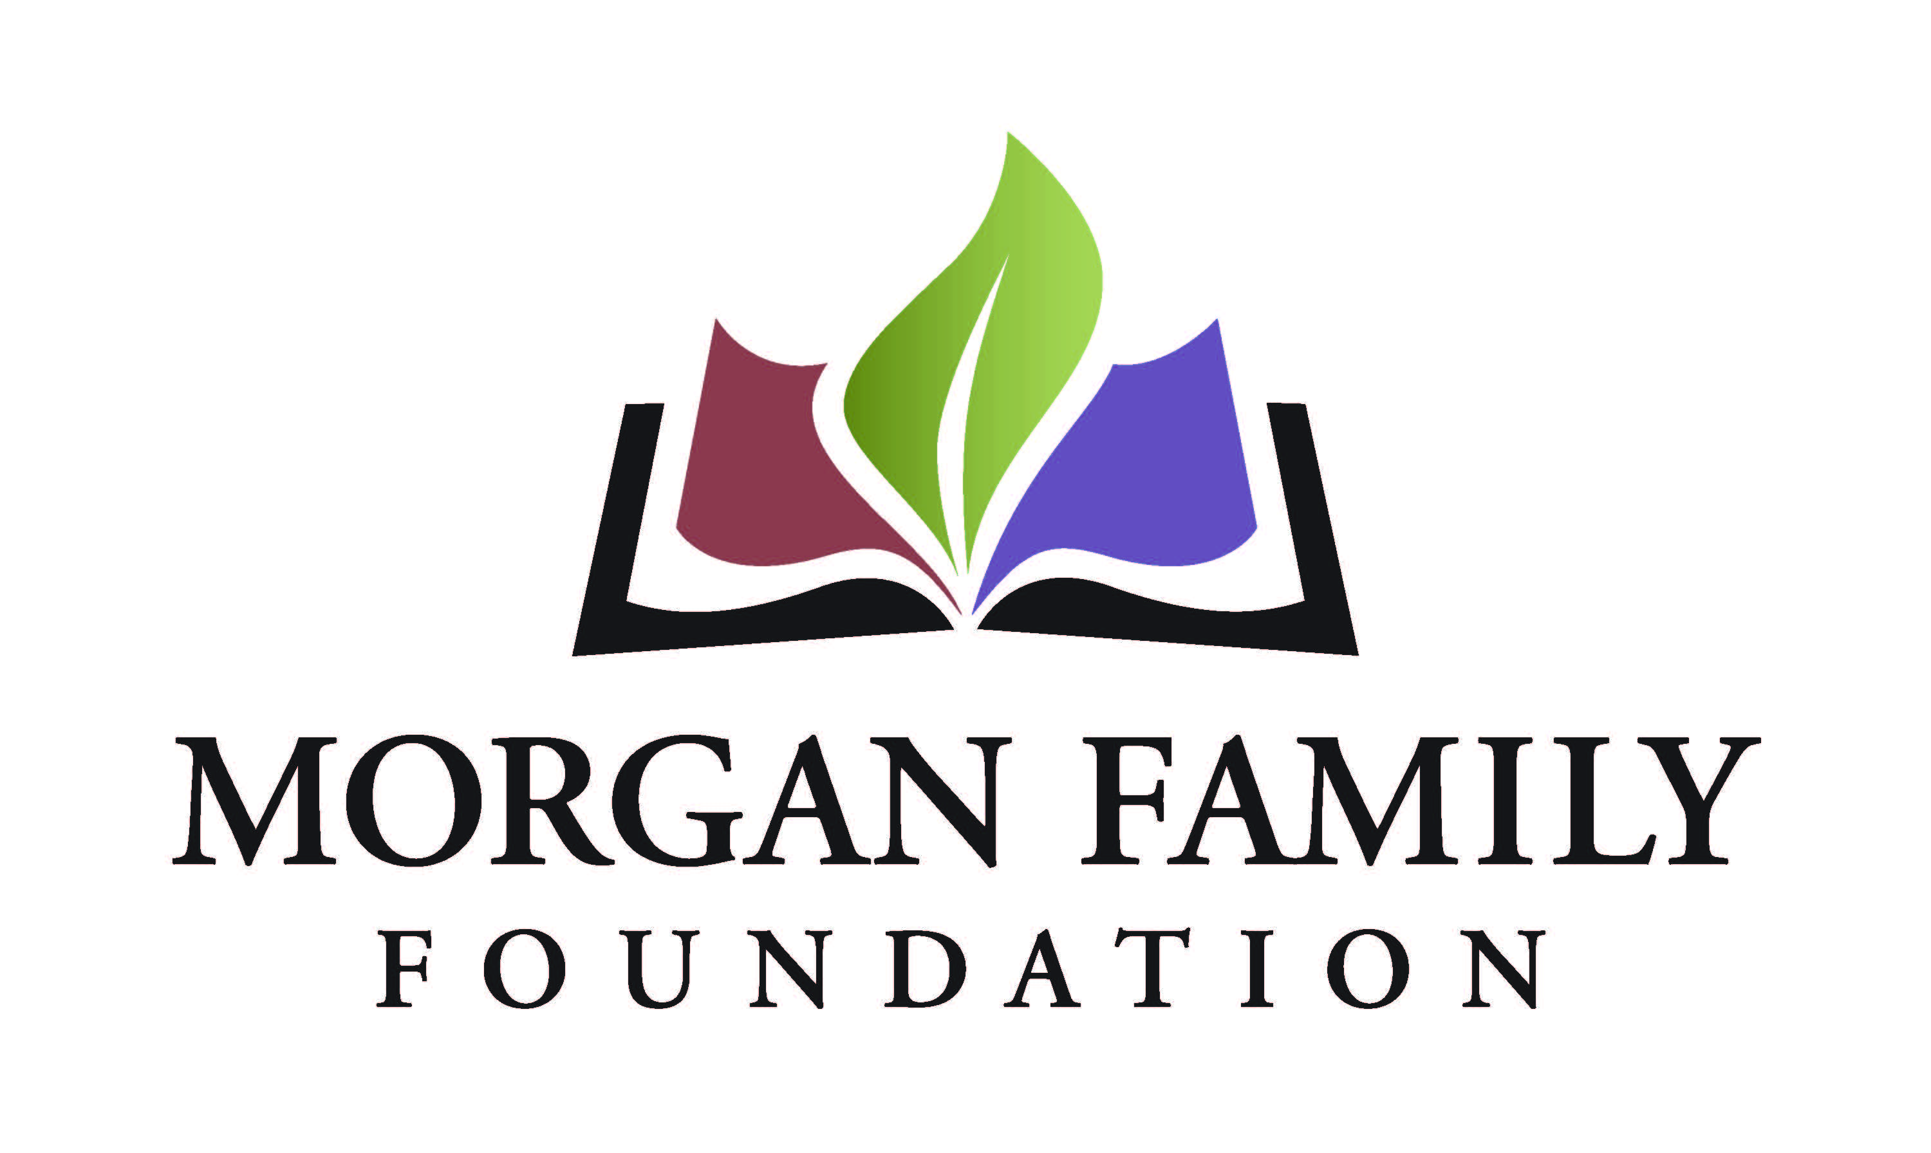
Guide for Grantee Interim Reports

The Morgan Family Foundation adopted this reporting format in order to monitor the progress of grantees and build greater consistency in how grantees report on their learning and accomplishments. Your candid responses to the questions below will help us better reflect on the impact of your work and our grantmaking.

Please complete the form and answer the reflection questions (Section III) in narrative form, either by inserting your text or attaching separate pages. Please limit your responses to a maximum of three (3) pages.

I. Grant Information
Organization Name
Grant Purpose (2-3 sentence description from award letter) ___________________________________________________________
Date of Grant Amount of Grant

II. Certification & Contact Information

By typing my name, title and date below, I certify that I am duly authorized to submit this report on behalf of the organization, and to the best of my knowledge the information contained herein is true, accurate and complete.

Print Name Title
Date_________________ Phone Email _____

III. Reflection
- Describe the progress you have made towards achieving the original goals of your grant thus far. You may include progress/impact on your organization, community, and population served.
- Describe unanticipated challenges or benefits that you have encountered to date.
- Describe any plans or changes to address unanticipated challenges or benefits encountered.

