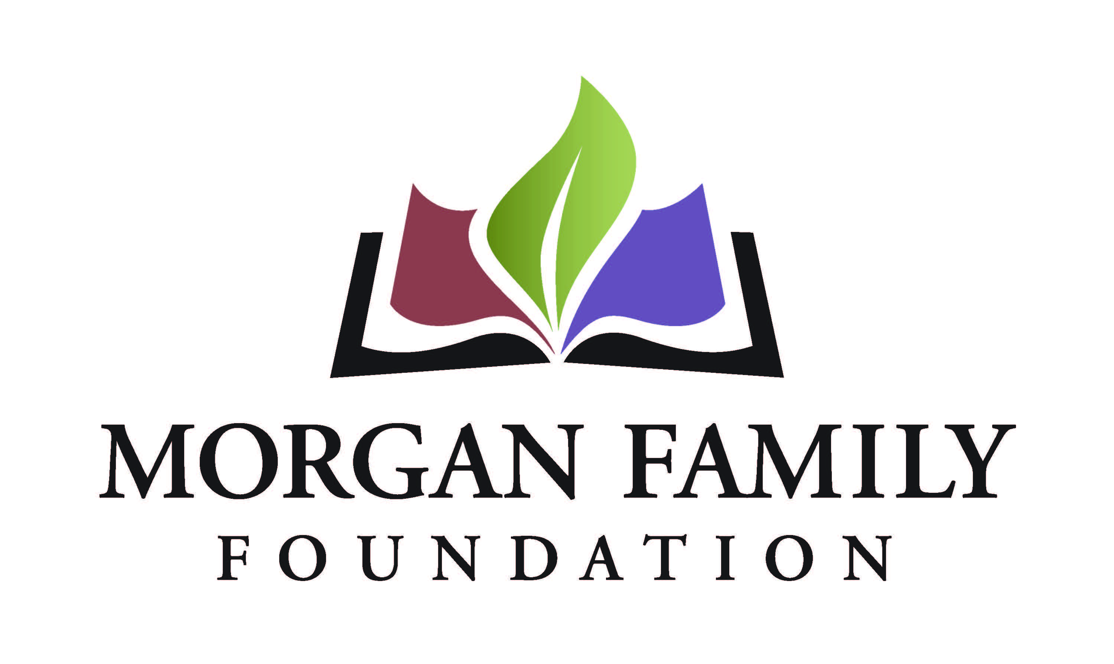
Grantee Final Report Form

The purpose of this reporting format is to monitor the progress of grantees and build greater consistency in how grantees report on their learning and accomplishments. Your candid responses to the questions below will help us better reflect on the impact of your work and our grantmaking.

Please complete the form and answer the reflection questions (Section III) in narrative form, either by inserting your text or attaching separate pages. Please limit your responses to a maximum of four (4) pages.

Attach the financial information as specified in Section IV. If you have any questions, please contact us.

I. Grant Information

Organization Name
Grant Purpose (2-3 sentence description from award letter) ______________________________________________________
Date of Grant Amount of Grant

II. Certification & Contact Information

By typing my name, title and date below, I certify that I am duly authorized to submit this report on behalf of the organization, and to the best of my knowledge the information contained herein is true, accurate and complete.

Print Name Title
Date_________________ Phone Email _____

III. Reflection

- Describe the progress you have made towards achieving the original goals of your grant. Include the impact it made on your organization, community, and population served.
- Describe unanticipated outcomes, benefits, or challenges that you encountered in the course of completing your goals.
- What are the most important results/lessons you have learned?
- If you were to undertake this project again what would you do differently?
- What are your future plans for sustainability? Briefly describe your rationale for expansion, replication, or termination.

IV. Financial Reporting
- Using the original budget included with your proposal, provide an itemized account of actual expenses and income for this period. Provide narrative on any variances of 10% or greater from the original project budget.
- Who else has funded this project, and at what level?

